Name: Soumyadeep Ganguly

Roll. No: 24MDT0082

Course: M.Sc. in Data Science

**Artificial Intelligence Lab**

**Course Code: PMDS601P**

**Assignment - 1**

**Code:**

parent(alice, dan).

parent(beth, eliza).

parent(charles, frida).

parent(dan, gerald).

parent(eliza, hank).

sibling(alice, beth).

sibling(alice, charles).

sibling(beth, charles).

sibling(X,Y):- parent(P, X), parent(P, Y), X\=Y.

cousin(X,Y):- parent(P1, X), parent(P2, Y), sibling(P1, P2).

second_cousin(X,Y):- parent(P1, X), parent(P2, Y), cousin(P1, P2).

**Output:**

1. 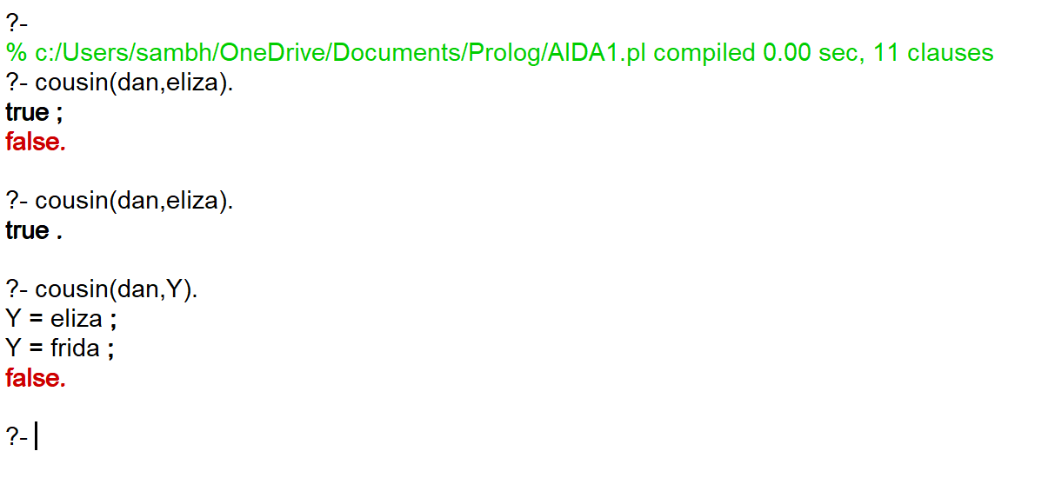Verify if Dan and Eliza are first cousins. Also print all first cousins of Dan.
2. Printing all the second cousins.

